STRAIN-INDUCED STABILISATION OF AUSTENITE AGAINST BAINITE TRANSFORMATION

S. B. Singh¹ and H. K. D. H. Bhadeshia²

¹Indian Institute of Technology, Kharagpur, India
²University of Cambridge, UK

S. B. Singh

Department of Metallurgical and Materials Engineering

Indian Institute of Technology, Kharagpur

Kharagpur 721 302

India

Fax: + 91 3222 82280

Email: sbs22@metal.iitkgp.ernet.in

Number of illustrations: 4 (Four)
Short title: Mechanical Stabilisation of Bainite

STRAIN-INDUCED STABILISATION OF AUSTENITE AGAINST BAINITE TRANSFORMATION

S. B. Singh¹ and H. K. D. H. Bhadeshia²

¹Indian Institute of Technology, Kharagpur, India
²University of Cambridge, UK

Abstract: Bainite, like martensite, forms by a displacive mechanism of transformation. Based on microstructural observation and microhardness measurements it has been concluded that prior deformation of austenite reduces the amount of bainite that can be obtained at a given isothermal transformation temperature. This clearly establishes that, similar to martensite, bainite also shows “mechanical stabilisation”.

INTRODUCTION

It is well established that deformation of austenite accelerates the ferrite transformation which forms by a reconstructive mechanism (1-3). Bainite and martensite, on the other hand, form by a displacive mechanism of transformation which involves a coordinated movement of atoms during the glide of the glissile interface (4). Such movements cannot be sustained against strong obstacles such as grain boundaries. Thus, martensite or bainite cannot cross grain boundaries. Defects such as dislocations also hinder the progress of any glissile interface in much the same way that ordinary slip is made more difficult by the presence of dislocation forests.

It follows that displacive transformations can be suppressed by prestraining the parent phase which has the effect of enhancing the matrix defect density. The effect is known as mechanical stabilisation and is well established for martensitic transformation (5). Prior deformation of austenite at temperatures sufficiently above M_{S} lowers the transformation temperature and the amount of martensite found at any subsequent temperature is reduced (5, 6).

The available literature on the mechanical stabilisation of austenite against bainite transformation indicates results similar to that for martensite though there are some apparent inconsistencies (7-10). Interference with other reactions such as formation of allotriomorphic ferrite prior to bainite transformation or precipitation of carbides during transformation makes the interpretation of results difficult. Difficulties may also arise if the transformation is allowed to progress under stress (11).

In the present work, we present some microstructural evidence which clearly establishes the mechanical stabilisation of austenite against bainite transformation.

EXPERIMENTAL PROCEDURE

The alloy used for this work was Fe-0.12C-2.03Si-2.96Mn (wt%). The alloy has sufficient hardenability with respect to bainite transformation. Moreover, Si suppresses the precipitation of cementite from austenite so that carbide-free upper bainite can be obtained. Bainite transformation can thus be studied without any interference from subsidiary reactions.

Experiments were carried out in an adapted Thermecmastor Z thermomechanical simulator using homogenised cylindrical samples (8mm diameter, 12 mm long). The samples were induction heated to 1200 ºC at 10 ºC s ^{–1} and held there for 180 s before being cooled to the deformation temperature of 700 ºC at 25 ºC s⁻¹. The samples were deformed in uniaxial compression to a predetermined strain at an average strain rate of 1 s⁻¹. They were then cooled rapidly to a selected isothermal transformation temperature using helium as the quenching gas. The alloy has sufficient hardenability to avoid any transformation before this isothermal treatment. A number of strains and isothermal transformation temperatures were studied. The isothermal transformation was allowed to progress without any externally applied stress. The samples were finally helium-quenched to ambient temperature after the completion of isothermal transformation to bainite. The entire operation was carried out in vacuum (4 x 10 ^{–2} mbar).

After the above thermomechanical treatment, the samples were sectioned longitudinally, ground, polished and etched in 2% nital for microstructural observation. Vickers microhardness tests were conducted using a Leitz miniload tester at a load of 4.903 N. The load was selected to allow a sufficiently large number of indentations per sample and at the same time sampling a reasonably large area of the microstructure per indentation to give an average hardness. The indentations were taken along the compression axis at intervals of 500 μm.

RESULTS AND DISCUSSIONS

The classical sheaf-like bainitic microstructure developed from undeformed austenite at all the isothermal temperatures studied; as typical examples, the microstructures corresponding to transformation temperatures of 500 ºC and 475 ºC are shown in Fig. 1. Consistent with incomplete reaction phenomenon, the amount of bainite increases as the transformation temperature is lowered (4). The micrographs of the samples deformed at 700 ºC and isothermally transformed at 500 ºC and 475 ºC are shown in Fig. 2 and 3. At each of these temperatures, the prior deformation of austenite is seen clearly to reduce the amount of bainite. The larger the prestrain, smaller is the quantity of bainite. It has been shown earlier that compressive deformation is inhomogeneous because of the tendency of the sample to barrel (12). Thus, less bainite is formed at the more heavily deformed centre than at the edge where the extent of deformation is less.

The reason for this mechanical stabilisation effect is as follows. Prior deformation of austenite introduces a large number of defects. These defects may raise the nucleation rate, but each nucleus transforms a smaller volume of austenite when it is plastically deformed (11, 13). The dislocations introduced by deformation block the motion of the austenite-bainite interface so that the plate growth is halted at a size which is much smaller than would be the case in the undeformed austenite. This leads to a reduction in the amount of bainite at any transformation temperature. The effect of transformation temperature is also clearly reflected in the microstructures that developed. At 500 ºC, deformation causes a large reduction in the amount of bainite. Hardly any bainite forms for a prestrain of 0.69 during transformation at 500 ºC. Prestrain was observed to have a smaller effect at lower transformation temperatures (e.g. at 475 ºC). The applied strain is less effective in restricting the growth of bainite plates at lower temperatures because of larger chemical driving force available for the growth of bainite.
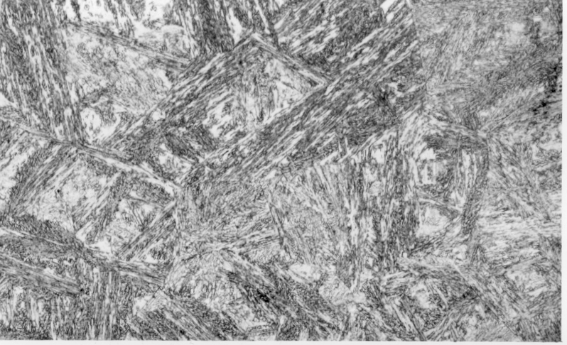
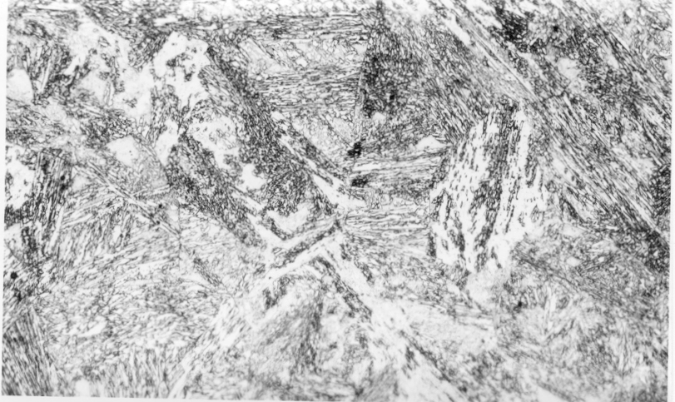
(b)
(a)

Fig. 1 Optical microstructure after completion of bainite transformation at (a) 500 ºC and (b) 475 ºC, 200 x

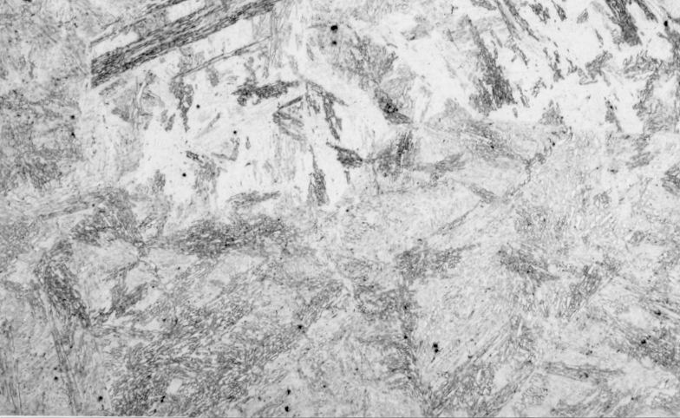
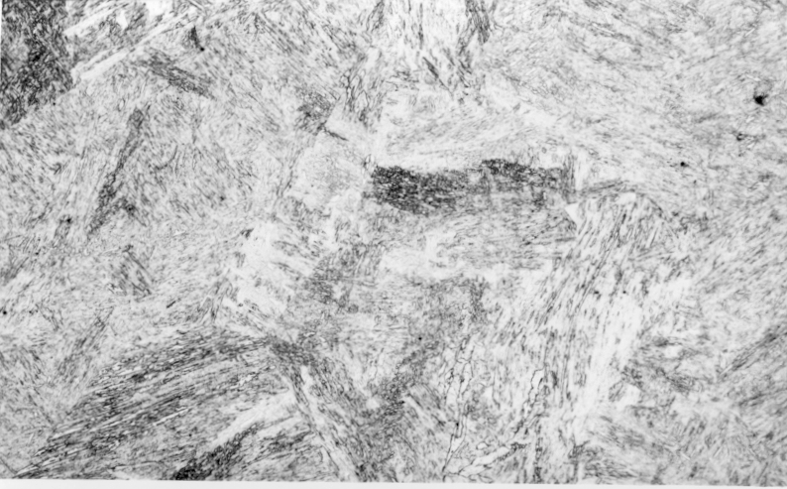

(b)
(a)

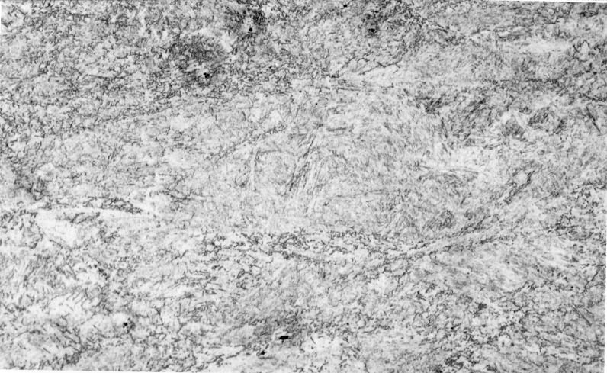
Fig. 2 Microstructure of the samples transformed at 500 ºC after uniaxial compression at 700 ºC. The longitudinal strain for (a) and (b) is 0.18 and that for (c) is 0.69. (a) is from the edge region and (b) and (c) are from the central region of the specimen, 200 x

(c)

Hardness data presented in Fig. 4 provide further evidence for the mechanical stabilisation effect. A decrease in the fraction of bainite with a concomitant increase in the fraction of martensite leads to a corresponding increase in the hardness. Deformed sample with a lower amount of bainite is therefore harder. For the deformed samples, the higher hardness at the sample centre compared with that towards the edge is due to the strain gradient along the compression axis and the resultant variation in the amount of bainite.

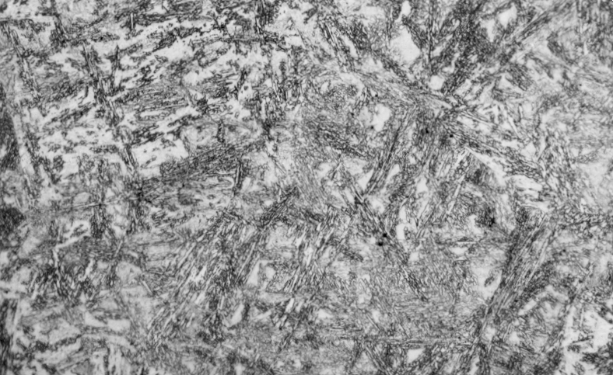
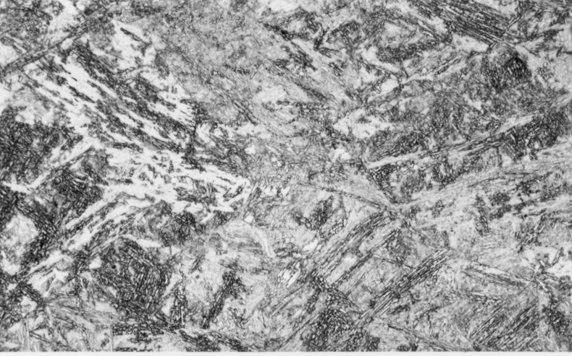

(b)
(a)

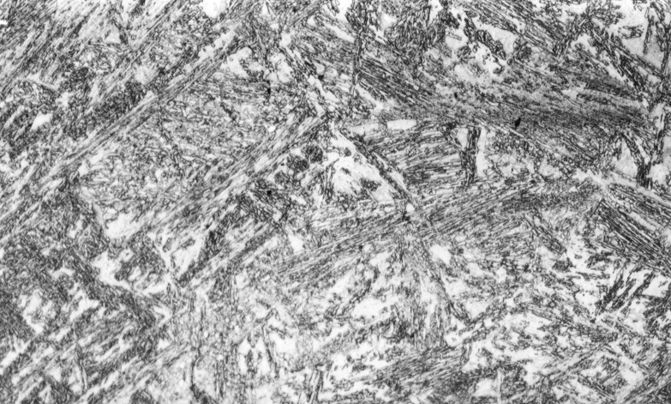
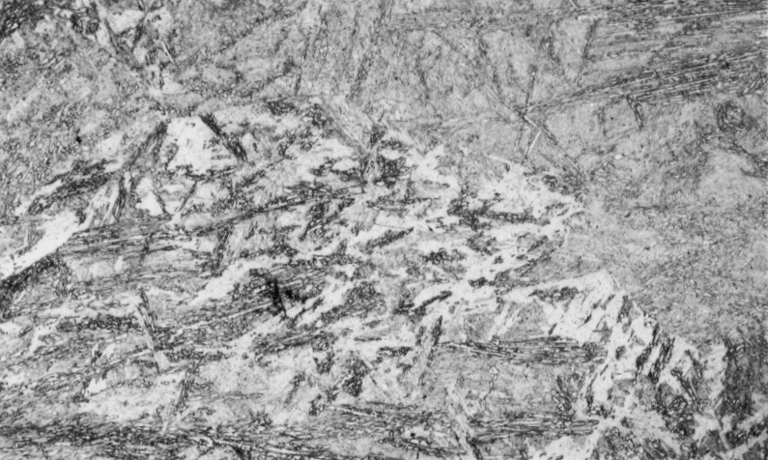

(d)
(c)

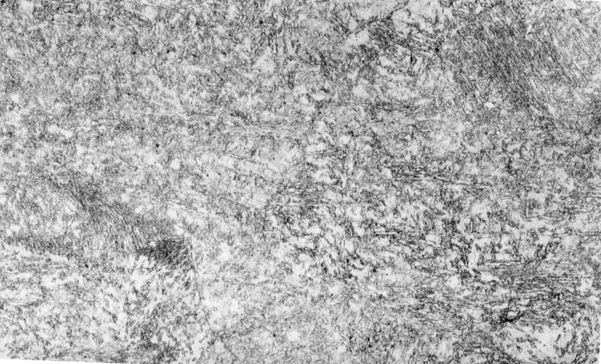
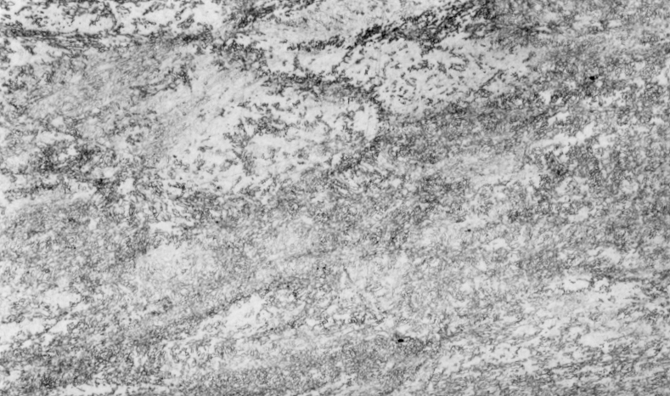

(f)
(e)

Fig. 3 Microstructure of the samples transformed at 475 ºC after uniaxial compression at 700 ºC. The longitudinal strain for (a) and (b) is 0.18, for (c) and (d) is 0.36 and for (e) and (f) is 0.69. (a), (c) and (e) are from the edge region and (b), (d) and (f) are from the central region of the specimen, 200 x

CONCLUSIONS

Direct microstructural evidence has been presented which clearly shows that like martensite, bainite transformation also shows mechanical stabilisation. Prior deformation of austenite lowers the quantity of bainite that is obtained at any temperature. Microhardness traverse across the inhomogeneously deformed specimen confirms the stabilisation effects.
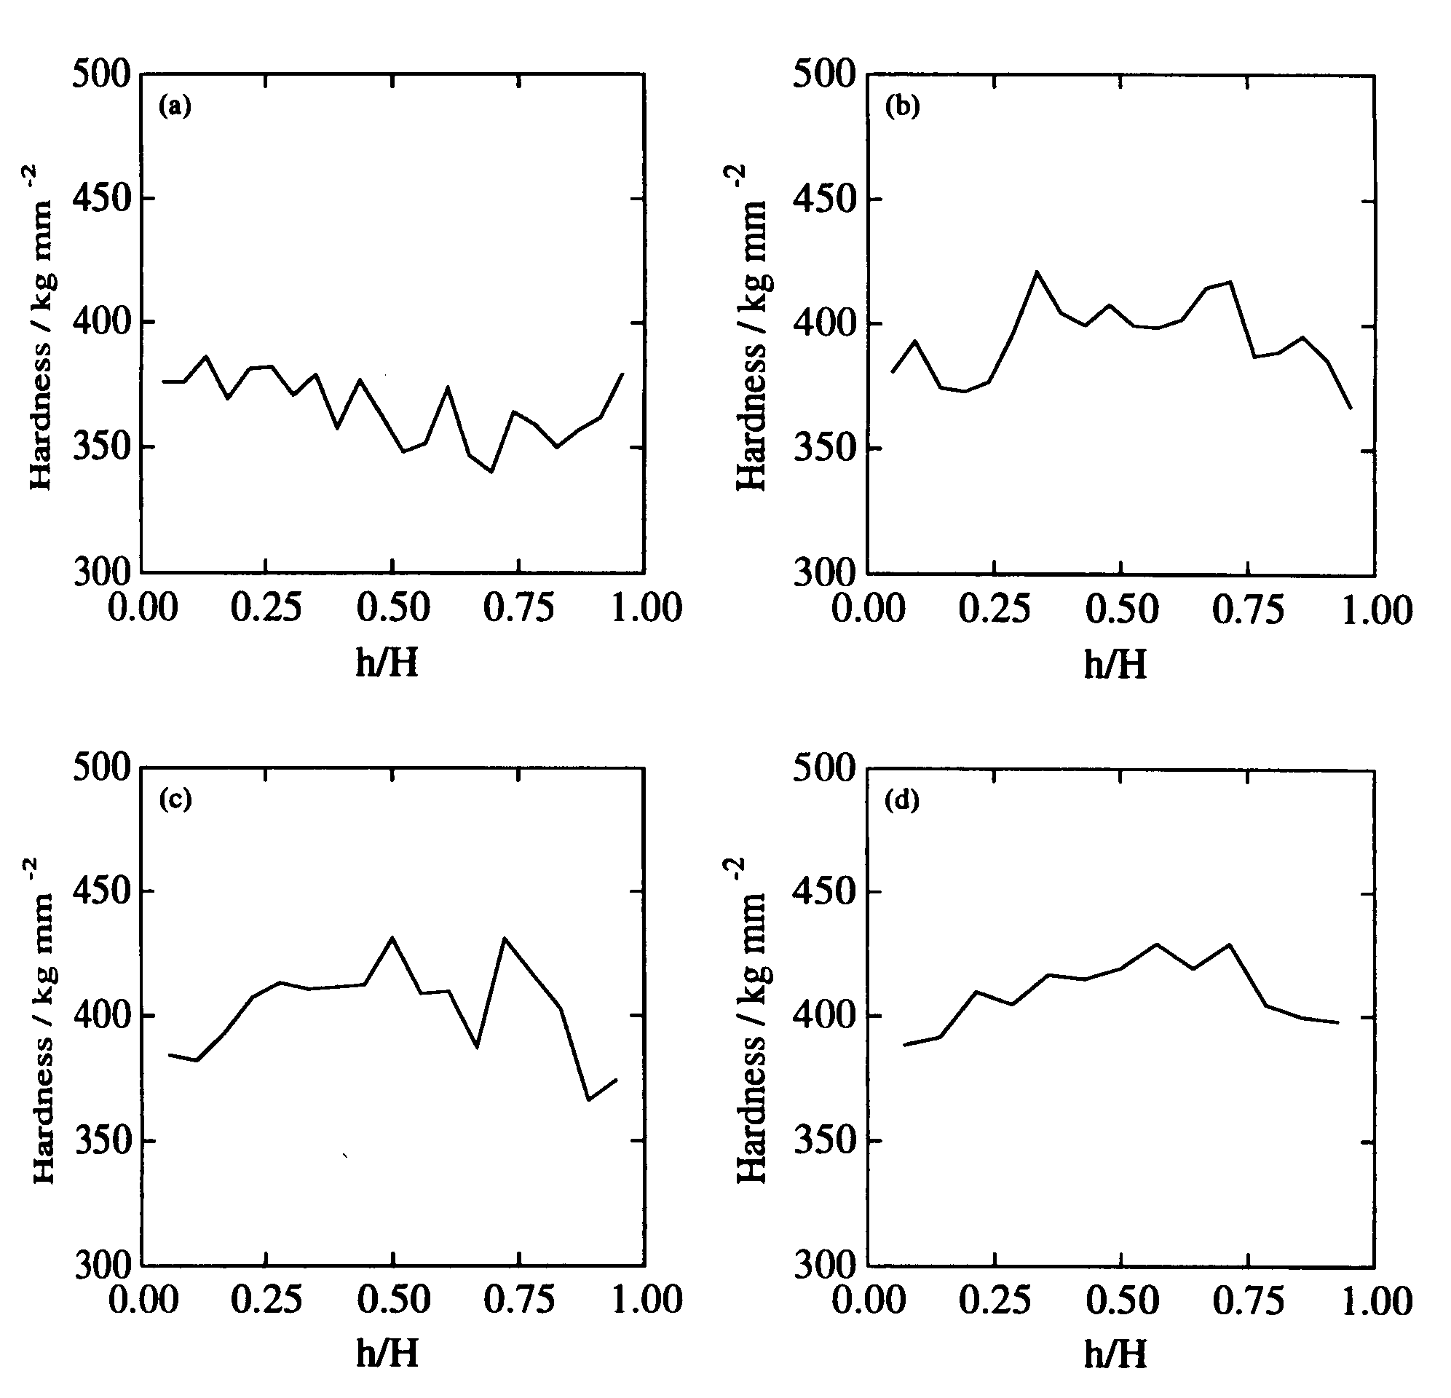
Fig. 4 Hardness profile of the samples compressed uniaxially at 700 ºC to various levels of strain and then isothermally transformed at 475 ºC. The strains are (a) 0.0, (b) 0.18, (c) 0.36 and (d) 0.69. H = Sample height, h = distance from the sample edge parallel to the compression axis.

REFERENCES

- R. K. Amin and F. B. Pickering, Thermomechanical Processing of Microalloyed Austenite, eds. A. J. DeArdo, G. A. Ratz and P. J. Wray, TMS-AIME, Warrendale, PA, USA, 1982, 377-402
- C. Ouchi, T. Sampei, I. Kozasu, Transactions of the Iron and Steel Institute of Japan, 22, 1982, 214-222
- G. R. Speich, L. J. Cuddy, C. R. Gordon and A. J. DeArdo, Phase Transformations in Ferrous Alloys, eds. A. R. Marder and J. I. Goldstein, TMS-AIME, Warrendale, PA, USA, 1984, 341-390
- H. K. D. H. Bhadeshia, Bainite in Steels, Institute of Materials, London, UK, (1992)
- V. Raghavan, Martensite, a Tribute to Morris Cohen, eds. G. B. Olson and W. S. Owen, ASM International, Materials Park, OH, USA, (1992), 197-226
- J. W. Christian, Theory of Transformations in Metals and Alloys, Part 1, 2nd edition, Pergamon Press, Oxford, UK, (1975)
- A. T. Davenport, The Hot Deformation of Austenite, ed. J. B. Balance, TMS-AIME, NY, USA, (1977), 517-536
- R. H. Edwards and N. F. Kennon, Metallurgical Transactions A, 9A, (1978), 1801-1809
- S. Yamamoto, H. Yokomaya, K. Yamada and M. Nikura, ISIJ International, 35, (1995) 1020-1026
- J. R. Yang, C. Y. Huang, W. H. Hsieh and C. S. Chiou, Materials Transactions, JIM, 37, (1996), 579-585
- S. B. Singh, Ph. D. Thesis, University of Cambridge, (1998)
- P. H. Shipway and H. K. D. H. Bhadeshia, Materials Science and Technology, 11, (1995), 1116-1128
- S. B. Singh and H. K. D. H. Bhadeshia, Materials Science and Technology, 12, (1996), 610-612

