Heat transfer modelling of this section enables us to make predictions of the thermal history of any point in the HAZ as a function of the weld multi-pass lay-up technique. Such a result for three nodes in the centre of the HAZ is shown in Fig. 14.

Fig. 14 Thermal Histories for the three nodes shown in Fig 13, from heat transfer modelling of the welding process, assuming that a series of passes are made during weld lay-up.
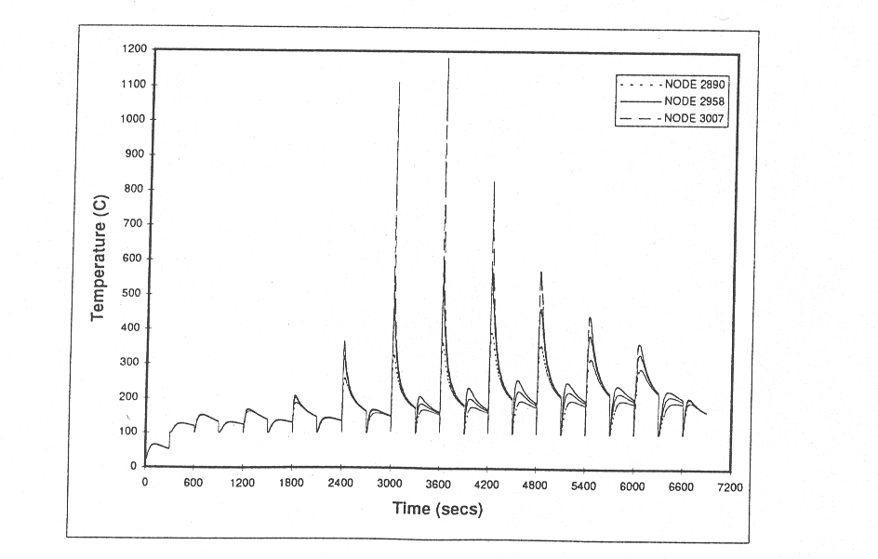

Fig. 15 Predicted Phosphorus Grain Boundary Segregation Profiles at Three Nodes shown in Fig. 13, using the thermal history data from Fig. 14.
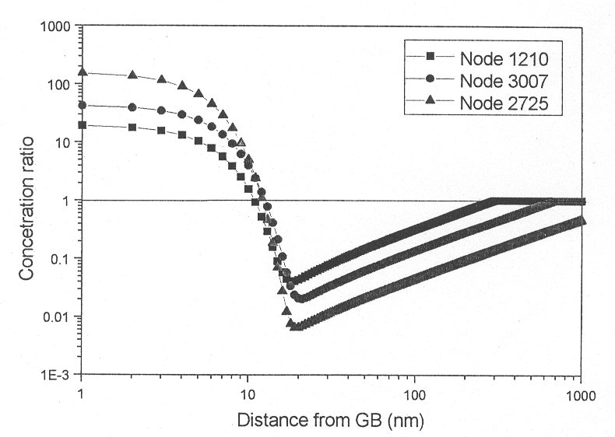
During the quenches as each pass is made strong NES effects regarding P and S are predicted. The shapes of the predicted GB concentration profiles at the three nodes close to the outer surface of the weld are shown in Fig.15. It is clear that substantial NES has taken place and that it is greatest in the region closest to the weld metal, where the quench rates are highest. No site competition or co-segregation arguments were applied to the modelling in this work. Since inter-granular cracking is observed in these welds precisely in the region where the nodes described in Fig. 13 exist, it seems reasonable that GB segregation of P and S is responsible for this failure.

Example 3. Thermodynamic delta ferrite weld metal analysis in Fe-12 Cr ferritic steel weldments.

A series of 16 weld metal compositions for Fe-12Cr steel weldments has been made up by creating a series of multipass welds on a ferritic steel base plate (see Table 2).
The materials have been examined experimentally and treated theoretically to identify the delta ferrite content [8]. This is because reduction of delta ferrite is known to improve the fracture toughness of the weld metal.

Table 2 Compositions of Weld metals (wt.%)
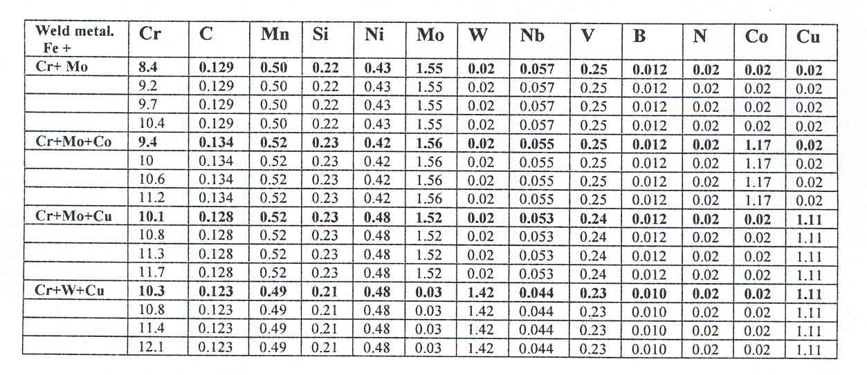

Compositions have a range of Cr equivalents that produce increasing amounts of delta ferrite. Additions of Mo, Cu, and Co have been made to the base compositions to see how the amounts of delta ferrite change. It is found that the amounts of delta ferrite are significantly less, for any alloy, in the centre bead portion than in the last bead portion (Figs. 16 and 17).

Fig. 16 Delta Ferrite (white) in Last Bead (x200)
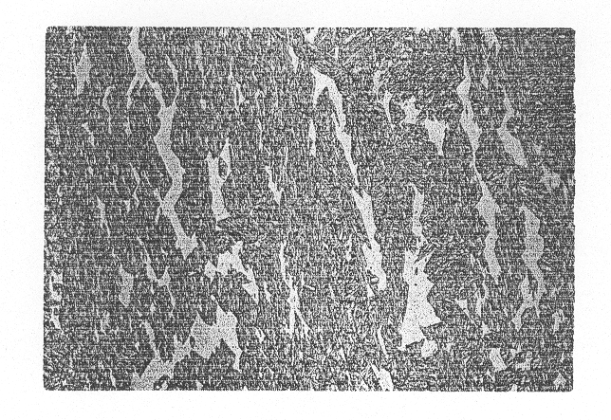

Fig. 17 Delta Ferrite (white) in similar weld in Centre Bead (x200)

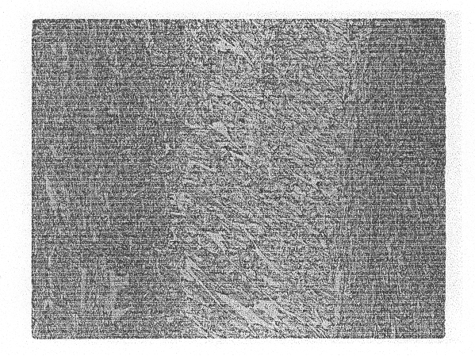

We have approached the modelling of this effect for the last bead situation by using thermal equilibrium diagrams for the steels using the comprehensive thermodynamic data package, MTDATA [9]. By taking tie-lines across the phase diagram at a temperature close to the solidification temperature in each of the phase diagrams computed from MTDATA, it is possible to predict the required concentration of Cr (2.20%) to cross the austenite /austenite + delta ferrite phase boundary (Fig. 18) [10]. The equivalent Mo required to cross this phase boundary in the same matrix alloy is shown in Fig. 19 and is equal to 1.55 % at the same temperature. This implies that the Cr equivalent of Mo for solidification of last bead to produce zero delta ferrite is 2.20/1.55 = 1.4. In a similar fashion all of the Cr and Ni equivalents can be estimated for the same temperature. A graph of the Cr – Ni equivalents, for all 16 alloys considered, plotted against the amount of delta ferrite results in all the points lying on the same straight line (Fig.20). This confirms that the predicted equivalents used,
Fig. 18 MTDATA Generated Diagram, showing Cr Equivalent at which Pure Austenite is Formed.
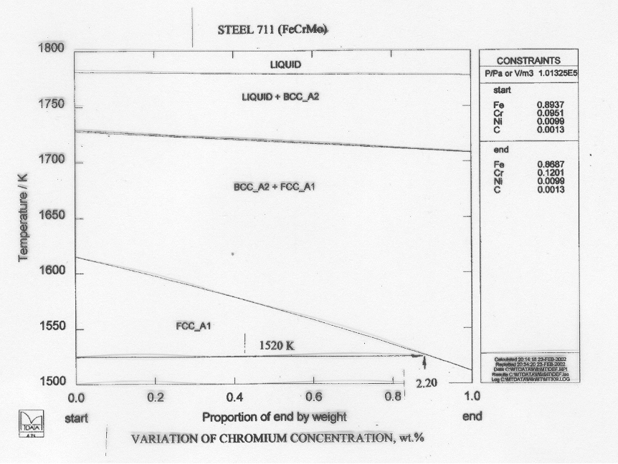

Fig. 19 MTDATA Generated Graph, showing Mo Equivalent at which Pure Austenite is Formed.
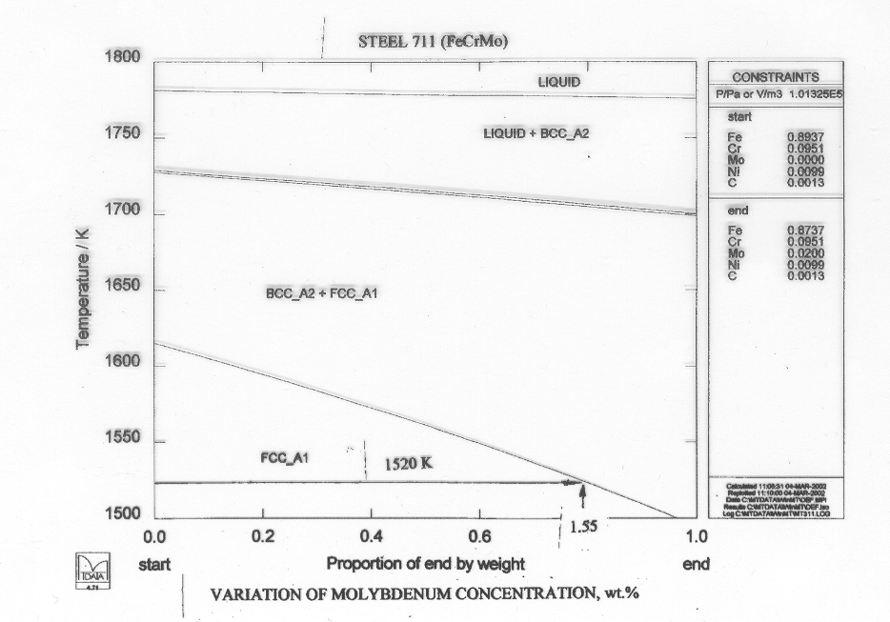

based on the MTDATA predictions, are valid for the ferritic steel compositions listed in Table 2. It is essentially a thermodynamic result which can be used to replace the old empirical predictions of Cr and Ni equivalents made by Shaeffler and others.

Fig. 20 Graph showing the Measured Delta Ferrite Content as a Function of Cr Equivalent minus Ni Equivalent, calculated from MTDATA-Generated Phase Diagrams from the Alloy Ranges Concerned
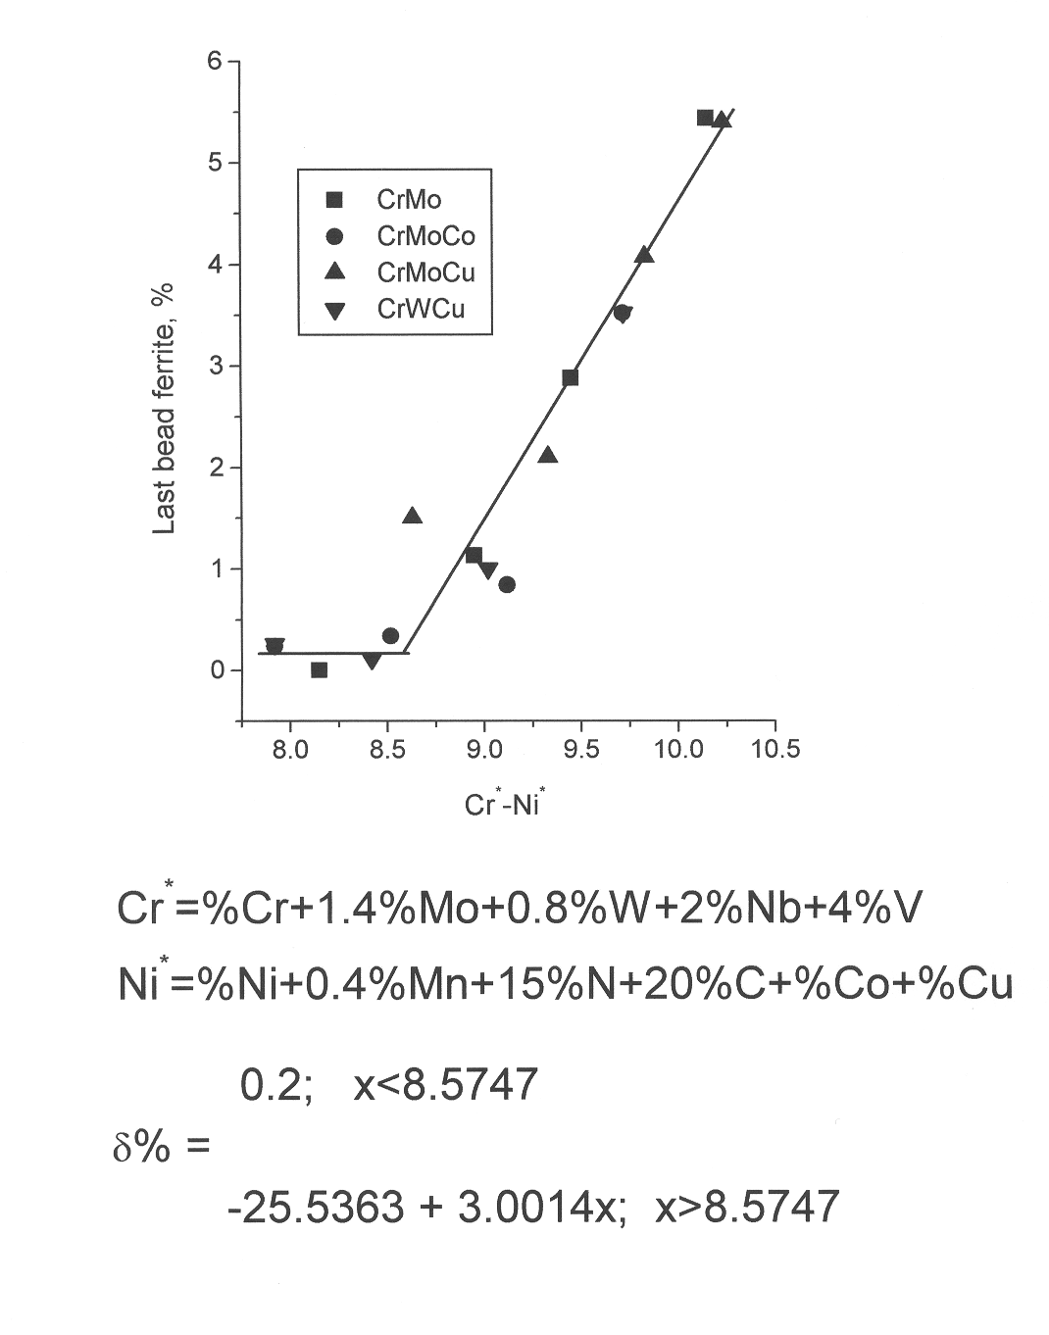

The last bead represents the true solidification situation. The centre bead sees considerable thermal excursions after solidification caused by subsequent weld passes on top of the bead, rather like those shown in Fig. 14. In this case substantial diffusion controlled phase transformations occur to bring the material to its equilibrium state at a lower temperature, somewhat below the solidification temperature. In this situation, less delta ferrite is expected for a given alloy composition. By choosing an appropriate temperature at which the solid state transformation from delta ferrite to austenite will take place, it is possible to predict the driving force for the transformation using MTDATA [11]. This driving force can be translated into a inter-phase interface velocity at the same temperature using a Wagner-type transformation kinetics analysis. Thus the reduction in the mean delta ferrite particle size and volume fraction can be calculated, assuming an appropriate time at the temperature at which the diffusion controlled transformation takes place. Predictions of the amount of delta ferrite removed in the centre bead of the ferritic steels weld metals are given in Fig. 21. It can be seen that the Co-containing alloys show a much reduced rate of delta-ferrite removal, mainly because the temperature at which the decomposition to austenite occurs is much lower than for the other alloys, e.g., Cu, in the series (Fig.22). The observations of the delta ferrite removal (equivalent to the delta ferrite difference) are shown in Fig. 23, confirming the theoretical prediction trends shown in Fig. 21.

Fig. 21 Theoretical Prediction of Delta Ferrite Removal Rate for Weld Metal Groups
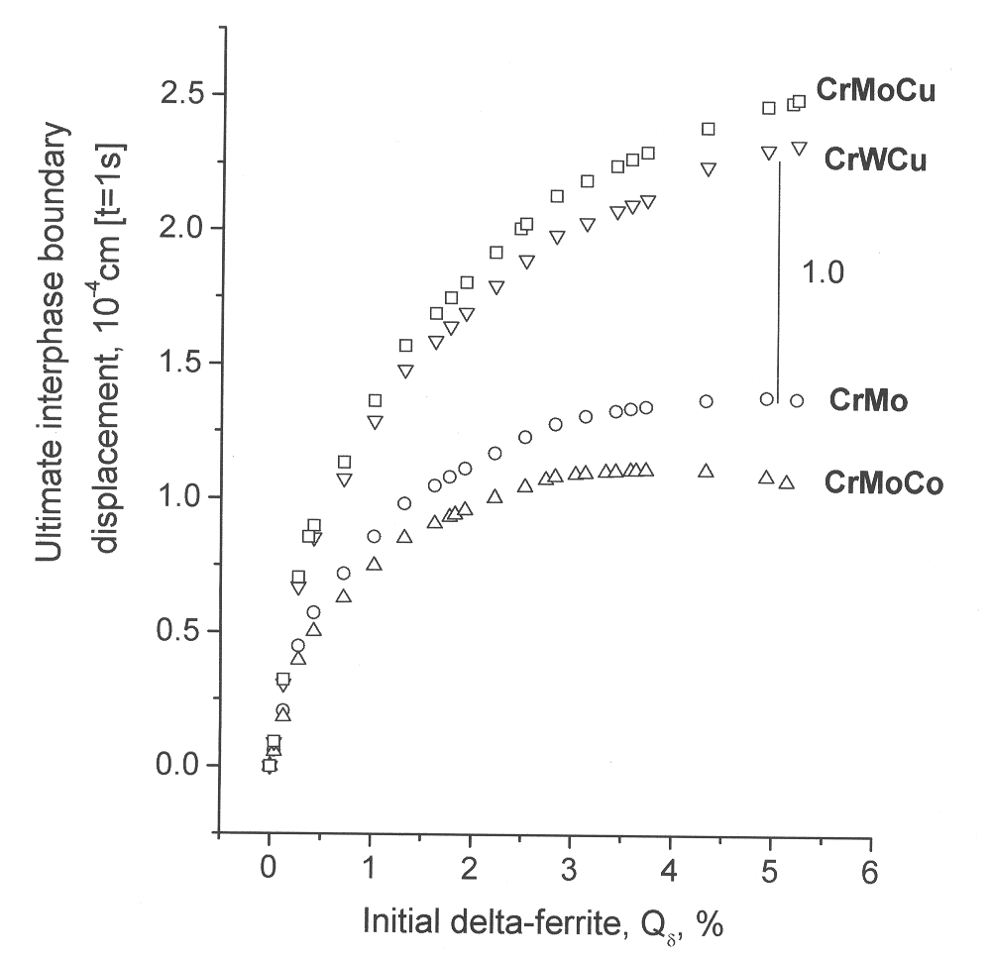

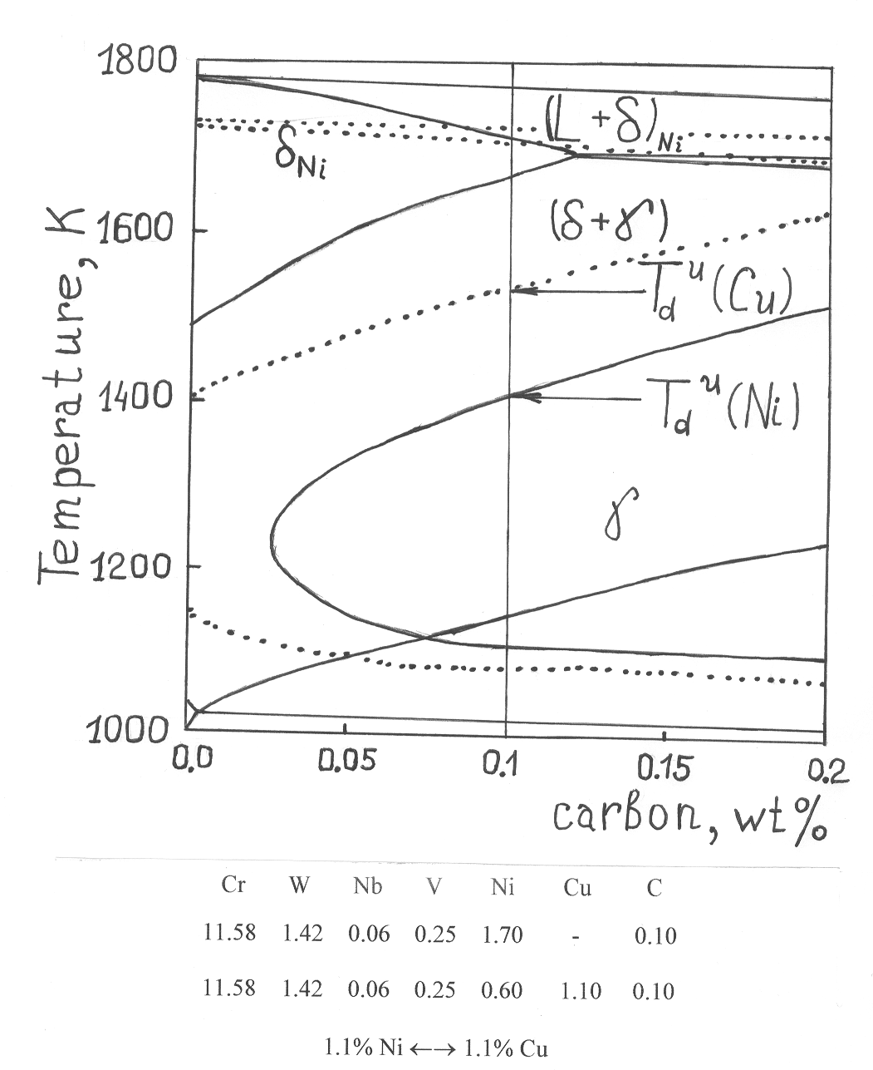
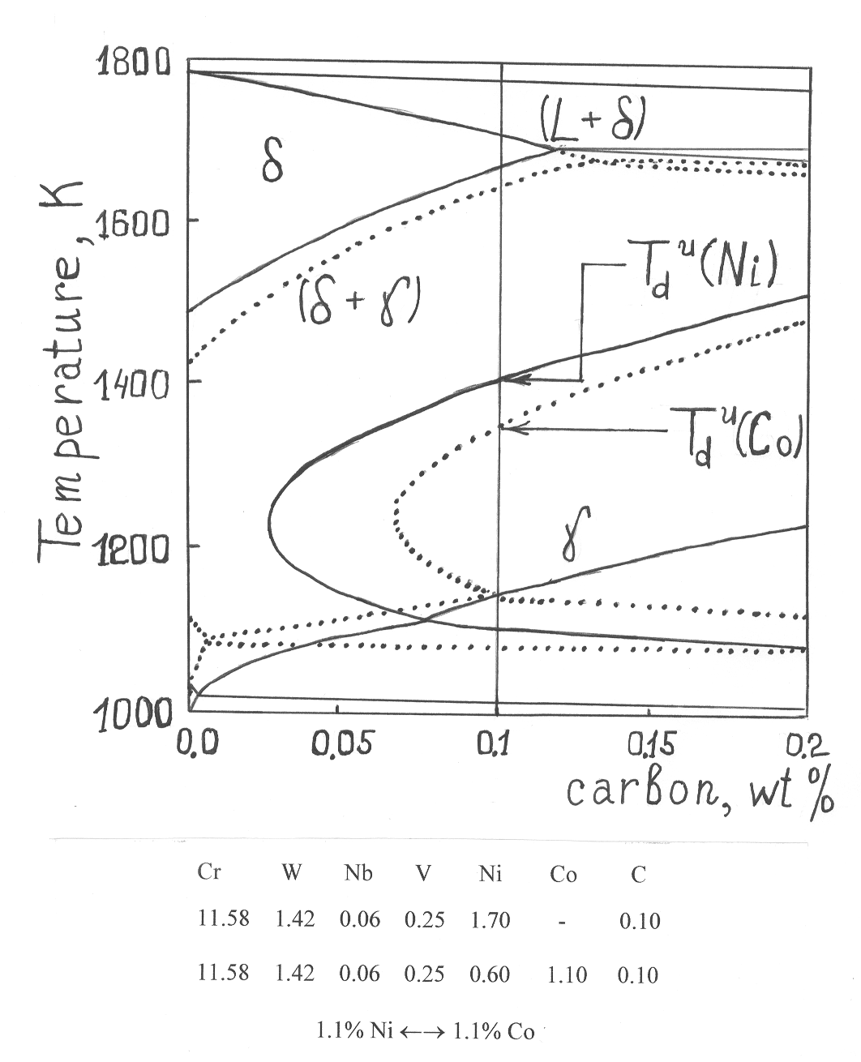
Fig. 22 MTDATA Generated Figures, showing the Reduced Temperature at which Delta Ferrite Removal is expected for the Co-containing, as compared to the Cu- containing Alloys

Fig. 23 Graph showing the Reduced Amount of Delta Ferrite Removal Observed for the Different Alloy Groups

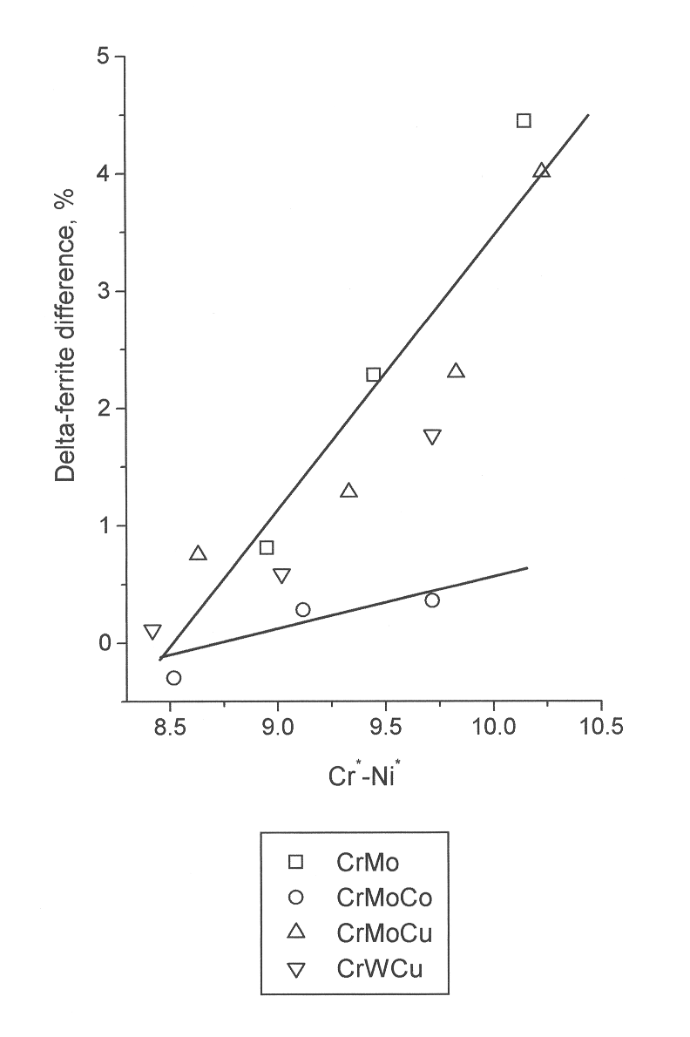

Conclusions

Modelling of weld microstructure has been described in ferritic steels, low alloy steels, C-Mn pressure vessel steels, austenitic steels, and ferritic steel weld metal. Intergranular segregation modelling has been discussed most prominently because many failures in welds of these steels are inter-granular. In the weld metal case thermodynamic modelling of delta ferrite formation, which is related to fracture toughness behaviour, has been described.

Acknowledgements

The author is indebted to many research students and assistants who have contributed to the studies discussed in this paper. They are: Shenhua Song, Duncan Meade, Colin Goodwin, Esteban Gonzales, Andrej Aleshin, Ben Sun, Petra Maier, and Adrian Williams. Financial support for the work has come from British Energy (Peter Flewitt), BNFL Magnox (Paul Spellward), DTI and Mitsui Babcock (Roger Maskell), EPSRC, and Metrode (Adam Marshall).

References

- R.G. Faulkner, Int. Mat. Rev., 1996, 41, 198.
- B. Sun, First year Ph.D. Report, Loughborough University, 2002
- P. Maier, R.G. Faulkner, P. Spellward, and J. Cowan, MST, 2001, 17, 1377.
- R.G. Faulkner, MST, 1989, 5, 1095.
- C.C. Goodwin and R.G. Faulkner, LUCL Report MP/BNF/039, 1999, Loughborough University
- S. Song and R.G. Faulkner, LUCL Report MP/NE/975, 1998, Loughborough University
- R.G. Faulkner, D. Meade and R. Hales, I. Mech. E. Conf. on ‘Integrity of High Temperature Welds’, Nottingham, 11 November 1998, p.345.
- R.G. Faulkner, J.A. Williams, E. Gonzalez Sanchez and A.W. Marshall, to be published in MST, March 2003
- R.H. Davies, A.T. Dinsdale, T.G. Chart, T.I. Barry and M.H. Rand, High Temperature Science, 1990, 26, 251.
- A.N. Aleshin and R.G. Faulkner, DTI COST 522 Report to Mitsui Babcock, March 2002.
- A.N. Aleshin and R.G. Faulkner, DTI COST 522 Report to Mitsui Babcock, September 2002.

